Data frames:

Data Frames are data displayed in a format as a table.

Data Frames can have different types of data inside it. While the first column can be character, the second and third can be numeric or logical. However, each column should have the same type of data.

Use the data.frame() function to create a data frame:

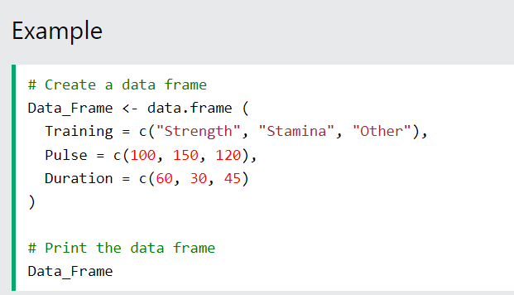

Summarize the Data

Use the summary() function to summarize the data from a Data Frame:



Access Items

We can use single brackets [ ], double brackets [[ ]] or $ to access columns from a data frame:

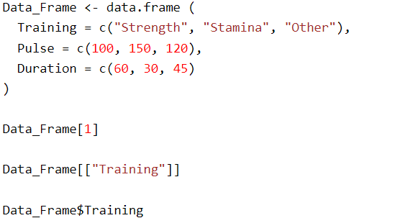

Add Rows

Use the rbind() function to add new rows in a Data Frame:

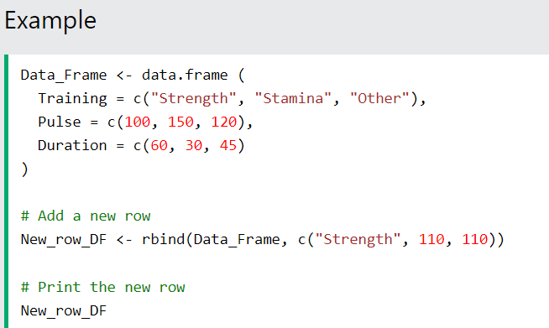

Add Columns

Use the cbind() function to add new columns in a Data Frame:

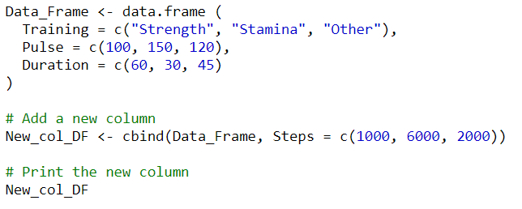

Remove Rows and Columns

Use the c() function to remove rows and columns in a Data Frame:

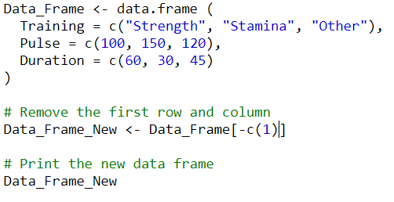

Amount of Rows and Columns

Use the dim() function to find the amount of rows and columns in a Data Frame:

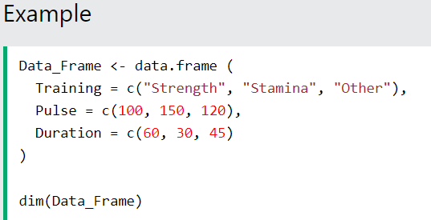

You can also use the ncol() function to find the number of columns and nrow() to find the number of rows:

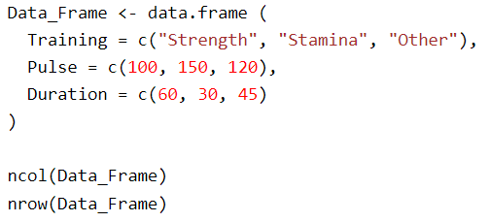

Data Frame Length

Use the length() function to find the number of columns in a Data Frame (similar to ncol()):

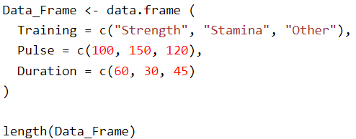

Combining Data Frames

Use the rbind() function to combine two or more data frames in R vertically:

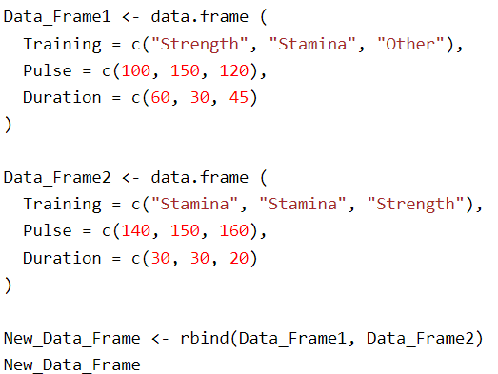

And use the cbind() function to combine two or more data frames in R horizontally:

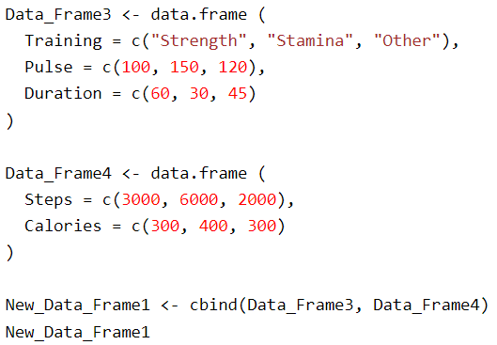

characteristics of data frames in R:

1. **Heterogeneous Data Types:** Columns can store different types of data, such as numeric, character, factor, or logical.
2. **Tabular Structure:** Data frames are 2D structures with rows representing observations and columns representing variables.
3. **Column and Row Names:** Columns and rows can be named for easier identification and access.
4. **Size Flexibility:** Data frames can vary in size, and additional rows or columns can be added or removed dynamically.
5. **Indexed Access:** Data frames allow for easy access to data via indexing, using row and column indices or names.